Consultation Questionnaire Exemption 8(e) of ELV Annex II

Table 1: Current wording of exemption 8(e
No. | Exemption | Scope and dates of applicability
8(e) | Lead in high melting temperature type solders (i.e. lead-based alloys containing 85 % by weight or more lead) | This exemption shall be reviewed in 2024

Acronyms and Definitions
COM European Commission
HMPS High melting point solder, i.e. solder with a lead content of 85 % by weight or more
Lead-free Not containing lead in the application in the scope of the exemption under review
Pb Lead

Background
Bio Innovation Service, UNITAR and Fraunhofer IZM have been appointed by the European Commission (COM) for the evaluation of applications for new exemptions and the renewal/continuation of exemptions currently listed in Annex II of the ELV Directive 2000/53/EC.
This questionnaire has been prepared for the stakeholder consultation held as part of the evaluation. The objective of this consultation is to collect information and evidence for subsequent review to assess whether the exemption is still justified according to the criteria listed in Art. (4)(2)(b)(ii) of Directive 2000/53/EC (ELV Directive).
Additional background information can be found on the exemption review page accessible through the following link: www.elv.biois.eu
We welcome your contribution to this stakeholder consultation. We recommend reading the below section before you answer the questions.

Main Observations in Previous Reviews
The above exemption was reviewed by Gensch et al. (2015) last time under the ELV Directive, and the consultants concluded that overall the use of lead was not yet avoidable. During the review, however, the applicants illustrated the manifold uses of lead-containing high melting point solders (HMPS) on the one hand but on the other hand strongly based argumentation and the efforts to find lead-free solutions on the activities of the DA5 Consortium since 2010 who focus on research to substitute lead in die attach. The same phenomenon can be observed in the report prepared by Baron et al. (2022) in the review of the request for renewal of the corresponding RoHS-exemption III-7(a). The underlying strategy has been that the DA5 find a lead-free solution for die attach and to use this substitute for all types of leaded HMPS applications, i.e. a 1:1 substitution of leaded HMPS by one single lead-free alternative for all the uses of this solder. So far, to the consultants’ best knowledge, this approach has not resulted in successful substitutions of lead in any applications where leaded HMPS have been used. Gensch et al. (2016) already raised doubts whether and how far a solution for lead-free die attach could be used to replace HMPS in all its other applications. Instead, application-specific research could be more promising, i.e. that lead-free solutions should be researched for individual, or for groups of applications with similar requirements.
Baron et al. (2022) aspired turning the purely material-specific exemption III-7(a) in the RoHS Directive towards a more application-specific one by structuring the various applications of the leaded HMPS solder as illustrated in the table on the next page. The COM’s official decision as to the recommended renewal of RoHS exemption III-7(a) is still pending.
Table 2: Renewal of current RoHS exemption 7(a) recommended by Baron et al. (2022)
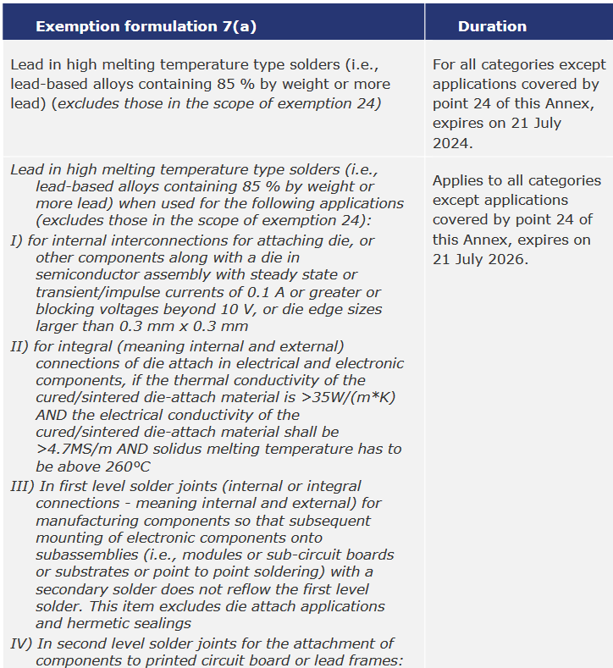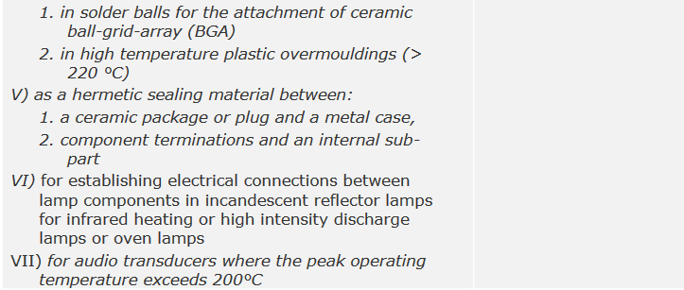
Source: Baron et al. (2022)

Questions
- What is the amount of lead that would be contained in in vehicles
  - placed on the EU market
  - worldwide
in case the exemption is continued beyond 2024? Please provide at least a rough calculation to substantiate your figures.

- Can you report any progress as to lead-free solutions for automotive applications that have been using leaded HMPS since the last review of exemption 8(e) by Gensch et al. (2015)?

- Can you think of any automotive application of leaded HMPS that would not be covered by the scope of the exemption proposed by Baron et al. (2022) in Table 2?

- Please describe your efforts to find lead-free solutions for the applications of leaded HMPS described in Table 2 as long as they are relevant for automotive uses, and for other applications (see question 3).

- Do you know of any promising materials or alternative technological approaches that could substitute lead in HMPS or eliminate the use of leaded HMPS?

- Please provide a roadmap specifying the past and necessary next steps/achievements in research and development including a time scale for the substitution or elimination of lead in this exemption.

- Overall, please let us know whether you agree with the necessity to continue the exemption and your arguments for or against the continuation.

- Is there any other information you would like to provide?

Your contact details
Name:
Entity:
E-mail:
Phone number:

Please note that answers to these questions can be published in the stakeholder consultation, which is part of the evaluation of this request. If your answers contain confidential information, please provide a version that can be made public along with a confidential version, in which proprietary information is clearly marked. Please also add “CONFIDENTIAL” to the file name to prevent confusion.
We ask you to kindly provide the information in formats that allow copying text, figures and tables so that they can be included into questionnaires and the review report.

References
Baron et al. (2022): Study to assess requests for a renewal of nine (-9-) exemptions 6(a), 6(a)-I, 6(b), 6(b)-I, 6(b)-II, 6(c), 7(a), 7(c)-I and 7 (c)-II of Annex III of Directive 2011/65/EU (Pack 22) – Final Report (Amended Version). Under the Framework Contract: Assistance to the Commission on technical, socio-economic and cost-benefit assessments related to the implementation and further development of EU waste legislation. in cooperation with Yifaat Baron, Carl-Otto Gensch, Andreas Köhler, Ran Liu, Clara Löw, Katja Moch, Oeko-Institut e. V.Baron et al.Yifaat Baron, Carl-Otto Gensch, Andreas Köhler, Ran Liu, Clara Löw, Katja Moch, Oeko-Institut e. V.https://​data.europa.eu​/​doi/​10.2779/​869784Study to assess requests for a renewal of nine (-9-) exemptions 6(a), 6(a)-I, 6(b), 6(b)-I, 6(b)-II, 6(c), 7(a), 7(c)-I and 7 (c)-II of Annex III of Directive 2011/65/EU (Pack 22) – Final Report (Amended Version)15 February 2022Baron et al.15 February 2022Yifaat Baron, Carl-Otto Gensch, Andreas Köhler, Ran Liu, Clara Löw, Katja Moch, Oeko-Institut e. V.https://​data.europa.eu​/​doi/​10.2779/​869784. Retrieved fromhttps://​data.europa.eu​/​doi/​10.2779/​869784.
Gensch et al. (2015): 7th Adaptation to Scientific and Technical Progress of Exemptions 8(e), 8(f), 8(g), 8(h), 8(j) and 10(d) of Annex II to Directive 2000/53/EC (ELV). Report (amended) for the European Commission DG Environment under Framework Contract No ENV.C.2/FRA/2011/0020, 1 July 2015. ELV IV. in cooperation with Carl-Otto Gensch, Yifaat Baron, Oeko-Institut and Dr. Otmar Deubzer, Fraunhofer IZMGensch et al.Carl-Otto Gensch, Yifaat Baron, Oeko-Institut; Dr. Otmar Deubzer, Fraunhofer IZMhttps://​circabc.europa.eu​/​sd/​a/​86a233f1-​93ce-​41e7-​b4f2-​06609a144e1e/​ELV-​Exemptions_​Amended_​Final_​2015-​06-​29.pdf7th Adaptation to Scientific and Technical Progress of Exemptions 8(e), 8(f), 8(g), 8(h), 8(j) and 10(d) of Annex II to Directive 2000/53/EC (ELV)1 July 2015Gensch et al.1 July 2015Carl-Otto Gensch, Yifaat Baron, Oeko-Institut; Dr. Otmar Deubzer, Fraunhofer IZMELV IVhttps://​circabc.europa.eu​/​sd/​a/​86a233f1-​93ce-​41e7-​b4f2-​06609a144e1e/​ELV-​Exemptions_​Amended_​Final_​2015-​06-​29.pdf (Adaptation to Scientific and Technical Progress of Annex II Directive 2000/53/EC, ELV IV). Retrieved fromhttps://​circabc.europa.eu​/​sd/​a/​86a233f1-​93ce-​41e7-​b4f2-​06609a144e1e/​ELV-​Exemptions_​Amended_​Final_​2015-​06-​29.pdf.
Gensch et al. (2016): Assistance to the Commission on Technological, Socio-Economic and Cost -Benefit Assessment Related to Exemptions from the Substance Restrictions in Electrical and Electronic Equipment - Study to assess renewal requests for 29 RoHS 2 Annex III exemptions. RoHS 14. in cooperation with Carl-Otto Gensch, Yifaat Baron, Markus Blepp, Katja Moch, Susanne Moritz, Oeko-Institut and Dr. Deubzer, Otmar, Fraunhofer Institut Zuverlässigkeit und Mikrointegration IZMGensch et al.Carl-Otto Gensch; Yifaat Baron, Markus Blepp, Katja Moch, Susanne Moritz, Oeko-Institut; Dr. Deubzer, Otmar, Fraunhofer Institut Zuverlässigkeit und Mikrointegration IZMhttps://​circabc.europa.eu​/​sd/​a/​eda9d68b-​6ac9-​4fb9-​8667-​5e561d8c957e/​RoHS-​Pack_​9_​Final_​Full_​report_​Lamps_​Alloys_​Solders_​June2016.pdfAssistance to the Commission on Technological, Socio-Economic and Cost -Benefit Assessment Related to Exemptions from the Substance Restrictions in Electrical and Electronic Equipment - Study to assess renewal requests for 29 RoHS 2 Annex III exemptions7 June 2016Gensch et al.7 June 2016Carl-Otto Gensch; Yifaat Baron, Markus Blepp, Katja Moch, Susanne Moritz, Oeko-Institut; Dr. Deubzer, Otmar, Fraunhofer Institut Zuverlässigkeit und Mikrointegration IZMRoHS XIVhttps://​circabc.europa.eu​/​sd/​a/​eda9d68b-​6ac9-​4fb9-​8667-​5e561d8c957e/​RoHS-​Pack_​9_​Final_​Full_​report_​Lamps_​Alloys_​Solders_​June2016.pdf (Adaptation to Scientific and Technical Progress of Annexes III and IV of Directive 2011/65/EU, RoHS XIV). Retrieved fromhttps://​circabc.europa.eu​/​sd/​a/​eda9d68b-​6ac9-​4fb9-​8667-​5e561d8c957e/​RoHS-​Pack_​9_​Final_​Full_​report_​Lamps_​Alloys_​Solders_​June2016.pdf.

It is implemented through the specific contract 070201/2020/832829/ENV.B.3 under the Framework contract ENV.B.3/FRA/2019/0017
ELV Directive, http://eur-lex.europa.eu/legal-content/EN/TXT/?uri=CELEX:32000L0053
C.f. EUR-Lex, http://eur-lex.europa.eu/legal-content/EN/TXT/?uri=CELEX:32000L0053
C-f- https://www.infineon.com/dgdl/DA5+Customer+Presentation+06042023.pdf?fileId=5546d4616102d26701610905cfde0005

